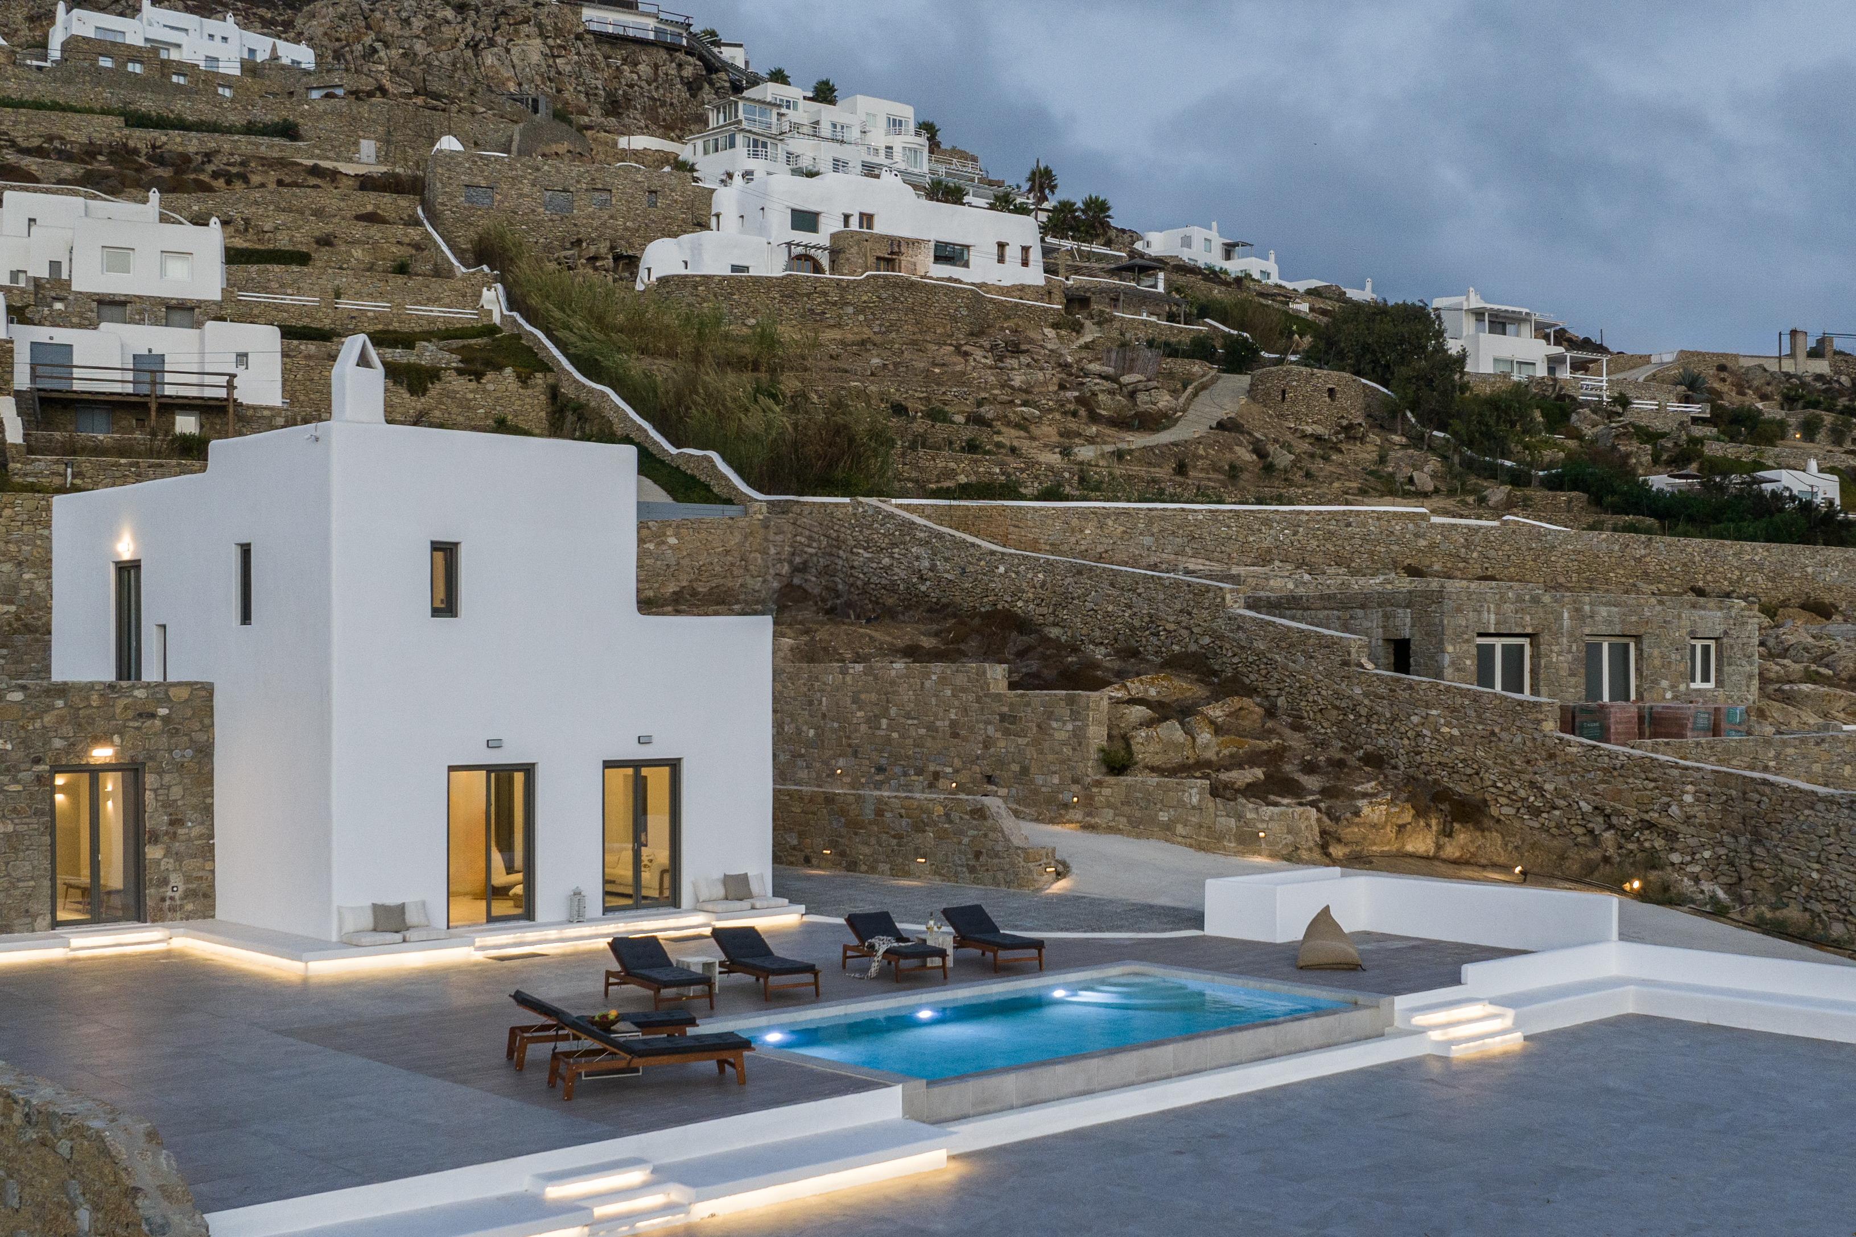

**Villa BouLevArt**

[**https://maps.app.goo.gl/uk9eugNehggMFkGe9**](https://maps.app.goo.gl/uk9eugNehggMFkGe9)

|  |  |  |
| --- | --- | --- |
| **Period** | **Daily Rate(euros)** | **Minimum Stay (nights)** |
| 1/5 – 15/5 | 400 | 3 |
| 16/5 – 31/5 | 500 | 3 |
| 1/6 – 15/6 | 650 | 3 |
| 16/6 – 1/7 | 850 | 3 |
| 1/7 – 15/7 | 1100 | 5 |
| 16/7 – 10/8 | 1300 | 5 |
| 11/8 – 31/8 | 1100 | 5 |
| 1/9 – 14/9 | 850 | 3 |
| 15/9 – 30/9 | 650 | 3 |
| 1/10 – 31/10 | 500 | 3 |

Calendar

iCal endpoint: <https://rest.reserve-online.net/ical/MOODMYK-MRVL.ics>

Availability URL: <https://mykonosmoodvillas.reserve-online.net/?room=MRVL>

Calendar: <https://www.rentalcalendarsdirect.com/display/yviewm/25506/>

Description:

Nestled in the beautiful area of Fanari, this newly built villa offers the perfect blend of elegance, modern design and tranquility. With its minimalistic aesthetic and clean lines, the villa excludes sophistication while remaining welcoming and comfortable. The in terior is bathed in natural light, thanks to large windows that frame stunning views of the surrounding landscape.

Whether you’re entertaining guests, enjoying quiet moments with family, or simply soaking in the beauty of your surroundings this villa is the ideal setting for a serene and stylish escape. With its contemporary design, exceptional comfort and stunning natural views, it promises unforgettable experience for those seeking a refined, tranquil retreat.

Layout:

Entrance level:

➢ Spacious living area with two comfortable sofas and large windows that open to the outdoor swimming pool area

➢ Fully equipped kitchen

➢ 1 Double bedroom with double sized bed and ensuite bathroom. Equipped with AC, wardrobe, safe box and has direct access to pool.

Upper Level:

➢ 1 Master bedroom with en-suite bathroom, AC, wardrobe, safe box and access to private balcony with 240’ sea view, sunset and pool view.

➢ 1 double bedroom with en-suite bathroom, AC, wardrobe, safe box and pool/sea view.

Outdoor area:

➢ Private swimming pool (2,5m x 7m)

➢ 6 sunbeds

➢ Outdoor lounge furniture

➢ Parking Zone (3 cars)